
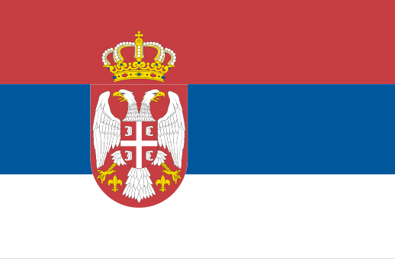

Bulgaria – Sebia IPA Cross-border Programme
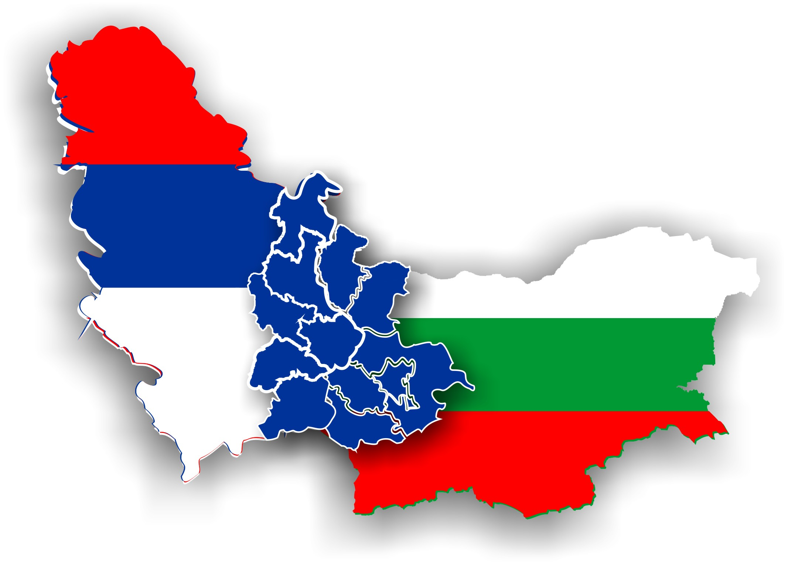

Ministry of Regional Development and Public Works of the Republic of Bulgaria
(Managing Authority)

in cooperation with
Ministry of Finance of the Republic of Serbia
(National Authority)
are seeking for project proposals for the promotion of cross border cooperation between Bulgaria and Serbia with financial assistance from the Bulgaria - Serbia IPA Cross-border Programme. Under present Call for Proposals an indicative amount of EUR 6.153.381 is available for the project proposals from both partnering countries. Project proposals would have to target one of the following priority areas:

- Development of small scale infrastructure
- Enhancing capacity for joint planning, problem solving and development

The ultimate objective will be to enhance the capability of the local and regional authorities to develop and implement joint projects within the border region in the following Bulgarian NUTS III level territorial units: Vidin, Montana, Sofia, Sofia –City, Pernik and Kyustendil and Serbian districts - Borski, Zajecarski, Nisavski, Pirotski, Jablanicki, Pcinjski.
.
The full Applicants Guide and Application Package are available for download on the following web page addresses: www.ipacbc-bgrs.eu , www.mrrb.government.bg and www.evropa.gov.rs

The deadline for submission of proposals is 30th November 2009, 16:00 local time in the address indicated in the Guidance for Applicants for the present Call for proposals. Information sessions on this call for proposals will be held in Bulgaria and Serbia. The dates and location of these sessions will be announced on the web sites www.ipacbc-bgrs.eu , www.mrrb.government.bg and www.evropa.gov.rs

Contact for additional information: JTS in Sofia: +359 2 9405 680, JTS Antenae office in Nis: +381 18 521 677, Ministry of Finance of the Republic of Serbia +381 11 3642 789

